Week-3 Experiment-3
Study of Network simulator tool and implement IP address configuration in Network simulator / Packet tracer tool
1. Open Cisco Packet Tracer and select the following devices
S.No Device Quantity
------ ---------- ------------
1. PC 4
2. Router 2

2. Use following IPv4 Addressing
S.NO Device IPv4 Address Subnet Mask Default Gateway
-------- -------- ------------------ ------------------- -------------------
1. PC0 192.168.10.1 255.255.255.0 192.168.10.2
2. PC1 192.168.20.1 255.255.255.0 192.168.20.2
3. PC2 192.168.30.1 255.255.255.0 192.168.30.2
4. PC3 192.168.40.1 255.255.255.0 192.168.40.2

3. Create the following topology and label the configuration as shown in the figure
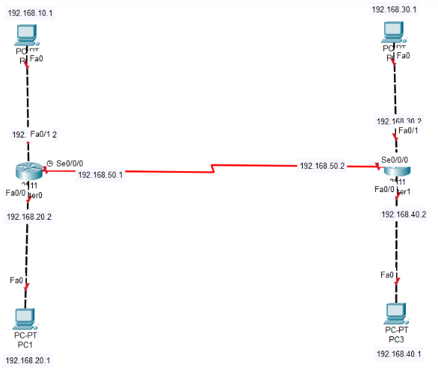
4. Assign the respective IP addresses and default gateways to all 4 PCs.
5. in Cisco Packet Tracer, assigning IP addresses to an interface of a router can either be done through the GUI mode or the command line.
6. Through GUI mode
- Click on any router and select the Config tab from the above tabs.
- Now find the interface to which you want to assign the IP address, from the tabs available on the left side of the window.
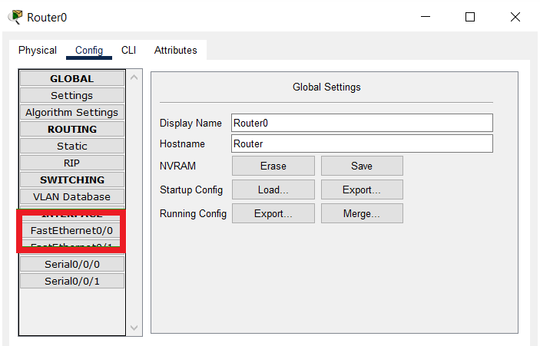
- After selecting the interface, fill in the IP address and the subnet mask in the fields named IPv4 Address and Subnet Mask.
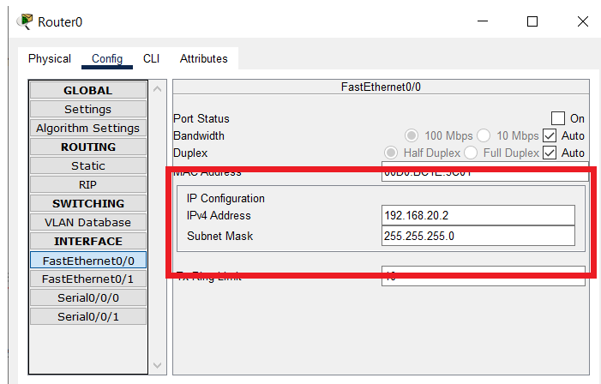

- Activate the port by checking the checkbox labeled as on for the Port Status option.
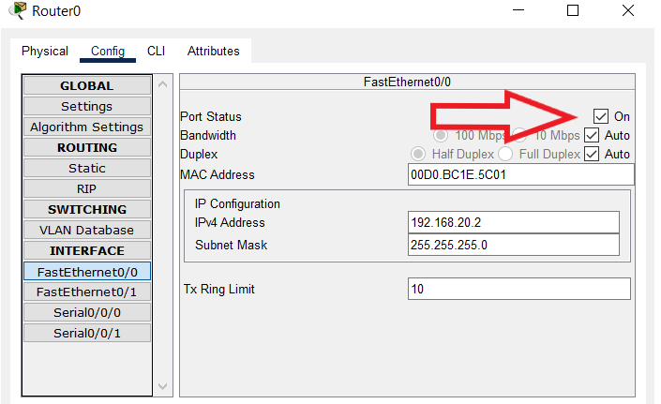
- Repeat the above steps for all the interfaces of the router, and then for all interfaces of other routers as well.
7. Run the ping command on command prompt to test N/w where sample Message is sent from one PC to another
From PC0 to PC3
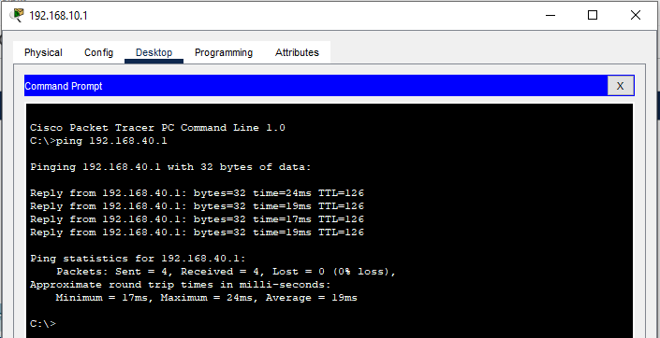
From PC0 to PC2
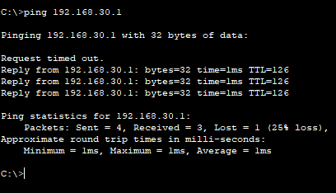

From PC0 to PC1
